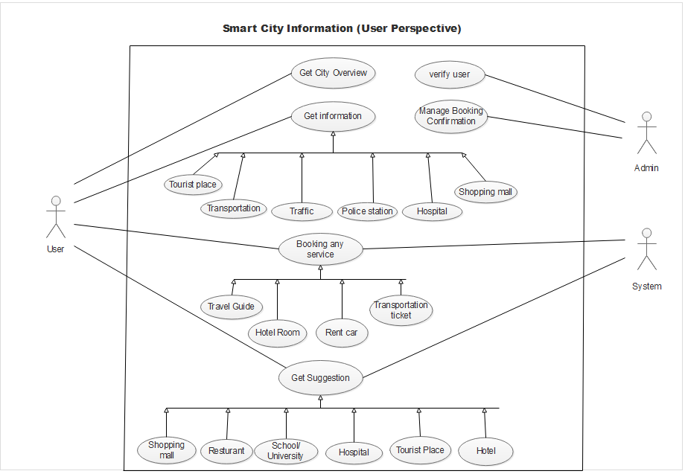

**Use Case:** Smart city Information (user perspective)

**Author:** Group 1

**Date:** 06/10/2021

**Purpose:** To draw the user section in the software and showing user’s functionality.

**Overview:** In this software user can get to know about the necessary information of a city and also can book various kind of services like hotel, car, transportation ticket and many more. User can also take suggestion about the city and its various sector. For getting information user don’t need to login but if user wants to get any service then he/she have to login and confirm identity. It’s also same for getting any suggestion about any place or any sector. Here admin will verify the user and also manage the booking confirmation system. On the other hand providing the necessary suggestion and showing available booking option will be control by the system.

**Actors:**

* Customer

* Admin

* System

**Pre Condition:**

* The user must have enough balance to confirm any booking.
* There must be free booking slot.

**Post Condition:**

* If user wants to cancel any booking he/she needs to confirm 2 days before the scheduled time.
* In case of any problem user must contact with the admin first.

**Typical Course of events:**

|  |  |
| --- | --- |
| Actor Actions | System Actions |
| 1. Begins when user enter into the software. |  |
| 1. User can get city overview or any information from the software. |  |
| 1. When user wants to book any service or get any suggestion he/she needs to provide his/her information. |  |
|  | 1. System verifies the information. |
| 1. Admin checks the validation and valid the user. |  |
| 1. User choose his/her preferable booking and suggestion option. |  |
|  | 1. System checks about the information and show result. |
| 1. For booking user select his option. |  |
|  | 1. System ask to confirm and make payment. |
| 1. User confirm the option and make the payment. |  |
|  | 1. System completes the payment and notify the admin. |
| 1. Admin confirms the booking and notify the user. |  |
| 1. User gets confirmation and completes the process. |  |

**Alternative flow of events:**

* Step 4: If system found that the information is not valid it notify the user and ask for valid information.
* Step 7: If system found that the chosen option is not available, it notify the user and ask for another option.
* Step 11: If system found that user doesn’t make the proper payment, it ask the user for proper payment.

**Exceptional flow of events:**

* Because of any failure in the system the confirmation system may not complete and user have to login again for the confirmation.